retailers

Maximum Marks

4 Marks

**Data Flow Diagrams:**

A Data Flow Diagram (DFD) is a traditional visual representation of the information flows within a system. A neat and clear DFD can depict the right amount of the

system requirement graphically. It shows how data enters and leaves the system, what changes the information, and where data is stored.

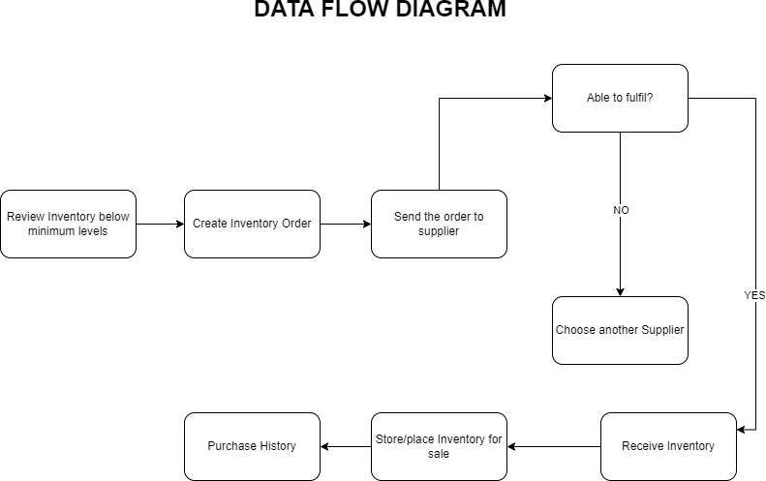

**Project Design Phase-II**

**Data Flow Diagram & User Stories**

Date

16 October 2022

Team ID

PNT2022TMID32730

Project Name

Project – Inventory Management for

dashboard with Facebook

Sprint-3

As a user, I can register for the application

I can register & access the

Low

USN-9

through Facebook

Sprint-2

I can register for the

As a user, I can register for the application

Medium

USN-10

Login

my password.

dashboard

user)

entering my email, password, and confirming

Sprint-1

I can access my account /

Customer (Web

High

As a user, I can register for the application by

USN-7

Registration

email & click confirm

once I have registered for the application

I can receive confirmation

As a user, I will receive confirmation email

Sprint-1

High

USN-8

I provide the answers for

USN-13

Support

levels.

products and inventory

products and inventory levels

Sprint-1

I can track data of sales of

users.

queries asked by users.

Executive

the queries asked by the

Sprint-1

As a Executive, I Provide answers for the

Customer Care

High

Sprint-1

High

I can log in by entering

As a user, I can log into the application by

USN-11

Login

application through Gmail

through Gmail

As a user, I can track data of sales of

High

USN-12

Dashboard

Gmail & password

entering email & password

my password.

dashboard

(Mobile user)

entering my email, password, and confirming

Sprint-1

I can access my account /

Customer

High

As a user, I can register for the application by

email & click confirm

once I have registered for the application

Sprint-1

High

I can receive confirmation

As a user, I will receive confirmation email

USN-2

**Functional**

**User Type**

**User Story**

Use the below template to list all the user stories for the product.

**User Stories**

USN-1

Registration

**(Epic)**

**Number**

**Requirement**

**Release**

**Priority**

**Acceptance criteria**

**User Story / Task**

High

entering email & password

Gmail & password

Sprint-1

I can log in by entering

As a user, I can log into the application by

USN-5

Login

As a user, I can track data of sales of

levels.

products and inventory levels

products and inventory

Sprint-1

High

I can track data of sales of

USN-6

Dashboard

through Facebook

As a user, I can register for the application

Login

dashboard with Facebook

As a user, I can register for the application

Sprint-3

Low

I can register & access the

USN-3

application through Gmail

through Gmail

Sprint-2

Medium

USN-4

I can register for the

Sprint-1

users

by performing basic CRUD operations.

by performing basic CRUD

operations

I can control all the users

USN-15

High

Control all the

As a administrator, I can control all the users

the database.

the database

I can control and access

Access the

USN-16

As a administrator, I can control and access

High

Sprint-1

database

**Acceptance criteria**

**Priority**

**Release**

**Requirement**

**Number**

**(Epic)**

**Functional**

**User Type**

**User Story**

**User Story / Task**

adding, shipping and

USN-14

High

Sprint-1

Manage the

As a administrator, I manage the stocks by

I manage the stocks by

Stocks

adding, shipping and storing the stocks in the

Administrator

storage units

storing the stocks in the

storage units.